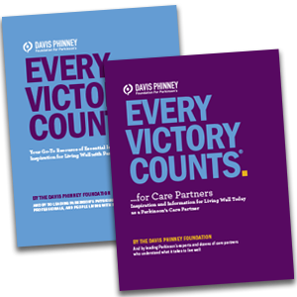

YOU CAN LIVE WELL WITH PARKINSON’S.
GET STARTED NOW.
First published in 2010, the Every Victory Counts® manual broke new ground as the only resource of its kind, devoted solely to the principle of proactive self-care and a holistic approach to managing Parkinson’s. In subsequent editions, it has gained international recognition as a superb and comprehensive resource for changing the way people live with Parkinson’s. Now in its sixth edition, the manual is the cornerstone of our new Every Victory Counts suite of resources, a robust collection of printed and digital manuals (including a new Every Victory Counts Manual for Care Partners) that embrace the Davis Phinney Foundation’s philosophy of taking action to improve your quality of life with Parkinson’s.
CLICK HERE TO ORDER YOUR MANUALS"
https://davisphinneyfoundation.org/every-victory-counts-manual/#evcorder

YOU'LL DISCOVER
- Essential information about Parkinson’s plus dozens of topics that are frequently overlooked but critical to helping you live well
- Insights from more than 50 Parkinson’s experts, including physicians, therapists, and scientists who share cutting edge research, strategies, and ideas for living well with Parkinson’s
- Advice and inspiration from dozens of people living well with Parkinson’s today
- In-depth information about exercise, nutrition, emotional health, medication, therapies, and more

EXPERT RECOMMENDED
AARON HAUG, MD
Board Certified Neurologist, Movement Disorder Specialist
“I appreciate the manual’s fundamental perspective, which is to empower people to live well with Parkinson’s today. I routinely recommend this manual to my patients, whether they are newly diagnosed or have been living with Parkinson’s for years.”

BRETT MILLER, PT
Owner and Founder of 110 Fitness
“As a physical therapist and owner of a Parkinson’s wellness center, I consider the Every Victory Counts manual to be the ‘PD bible’. It’s a gift I give to every person that steps in my facility with Parkinson’s.”

SARAH KING, PT, DPT
“The information that’s covered in the manual is critical to helping people slow the progression of Parkinson’s. When my clients start implementing what they’ve learned, their entire world starts to change for the better and they feel hope again.”

AL CONDELUCCI, PHD
Advocate and Family Member
“I can’t tell you how impactful the manual has been. Families constantly testify to how useful the manual has been in their own Parkinson’s journey. In fact, it is rare to find a publication that has such a profound consumer impact.”


ORDER TODAY
You can order the Every Victory Counts manual, the Care Partner manual, or both. Both manuals are available in print and digital formats.
Use the buttons below to request your free copy of the Every Victory Counts manual and/or Care Partner manual to be shipped within the United States or download the digital version and dive in today.
New! Parkinson Canada is proud to partner with the Davis Phinney Foundation to bring the Every Victory Counts manual to Canadians affected by Parkinson’s. Click here to sign up and be the first to get your free copy.
GET THE DIGITAL EDITIONS
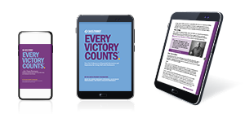
GET THE PRINT EDITIONS
